**Static Variable & Method**

1. Write a program to create a static variable and display the value outside the class.
2. class **sample**:
3. a=10
4. b=12
5. pass
6. print(sample.a)
7. print(sample.b)

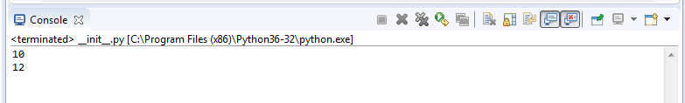

2. Write a program to create a static variable. Create two object and initialize different instance variable for the created objects. Access the static variable and instance variable using the object.

class sample:

a=10

b=12

pass

on=sample()

ob=sample()

ob.b=66

on.b=11

print("object:",ob.a,ob.b)

print("object:",on.a,on.b)

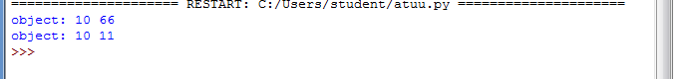

3. Write a program to create a static variable. Create two object and initialize different instance variable for the created objects. Update the value for the static variable and access the static variable and instance variable using the object.

class sample:

a=10

b=12

pass

on=sample()

ob=sample()

ob.b=66

on.b=11

ob.a=44

on.a=88

print("object:",ob.a,ob.b)

print("object:",on.a,on.b)

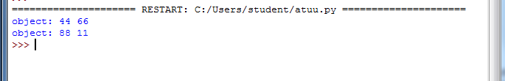

4. Write a program to create a static variable. Create two object and initialize different instance variable for the created objects. Update the value for the static variable (using the class identifier) and access the static variable and instance variable using the object.

class sample:

a=10

b=12

pass

on=sample()

ob=sample()

ob.b=66

on.b=11

ob.a=44

on.a=88

sample.a=100

print("object:",ob.a,ob.b)

print("object:",on.a,on.b)

print("Constracter",sample.a)

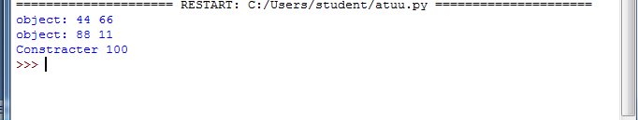

5. Write a program to create the static method and access the static method using the class and object instance for the specified class.

class sample:

a=10

b=12

@staticmethod

def staticmethod():

print("Static Method",sample.a)

pass

ob=sample()

print(sample.a)

ob.staticmethod()

